UCONN PARKING Lot D

You should park in Lot D (Employee Lot). You may park in any space in Lot D (see red circle on map below). See Driving Directions for getting to Avery Point and picture of Marine Sciences Building below.

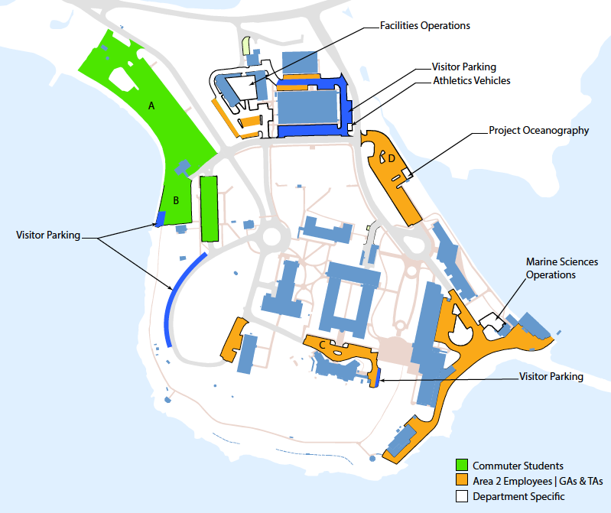
Parking Lot D
Marine Science Building

Driving Directions

Campus Map: http://averypoint.uconn.edu/wp-content/uploads/sites/543/2014/07/AveryPoint_Parking_Lots-3.21.16.pdf

University of Connecticut Avery Point Campus
1080 Shennecossett Rd
Groton, CT 06340
From the east (Providence, Boston) – Take I-95 S to exit 87 (left side exit), Clarence B. Sharp Hwy/CT-349 toward US-1 (1.9 mi). At the second set of stoplights take a right (you will see a sign here for the University of Connecticut at Avery Point). At the next corner and set of lights, take a left. Follow this road for several miles, straight, past Pfizer and the Shennecossett Golf Course. Shortly after the golf course you will come to the entrance on the right side for the University (big blue sign) just before a sharp curve.
From the west (New Haven, New York) – Take I-95 N to exit 87 Clarence B. Sharp Hwy/CT-349 toward US-1 (1.9 mi). At the second set of stoplights take a right (you will see a sign here for the University of Connecticut at Avery Point). At the next corner and set of lights, take a left. Follow this road for several miles, straight, past Pfizer and the Shennecossett Golf Course. Shortly after the golf course you will come to the entrance on the right side for the University (big blue sign) just before a sharp curve.
From the north (Norwich, Worcester) – Take I-395 S to exit 78 (left side exit) toward CT-32/New London (0.4 mi). Merge onto Montville Connector (0.9 mi). Slight right at CT-32/Mohegan Avenue Parkway; continue to follow CT-32 (3.3 mi). Merge onto I-95 N/US-1 N via the ramp to Providence/Groton (1.7 mi). Take exit 87 Clarence B. Sharp Hwy/CT-349 toward US-1 (1.9 mi). At the second set of stoplights take a right (you will see a sign here for the University of Connecticut at Avery Point). At the next corner and set of lights, take a left. Follow this road for several miles, straight, past Pfizer and the Shennecossett Golf Course. Shortly after the golf course you will come to the entrance on the right side for the University (big blue sign) just before a sharp curve.
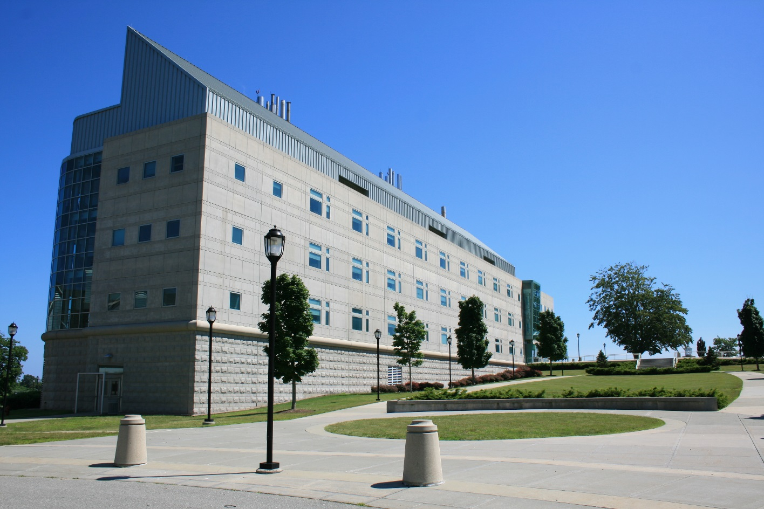

Marine Science Building: located next to the Branford House on the UConn Avery Point Campus.

